**IBM X-Force IRIS**

**Hotline Numbers**

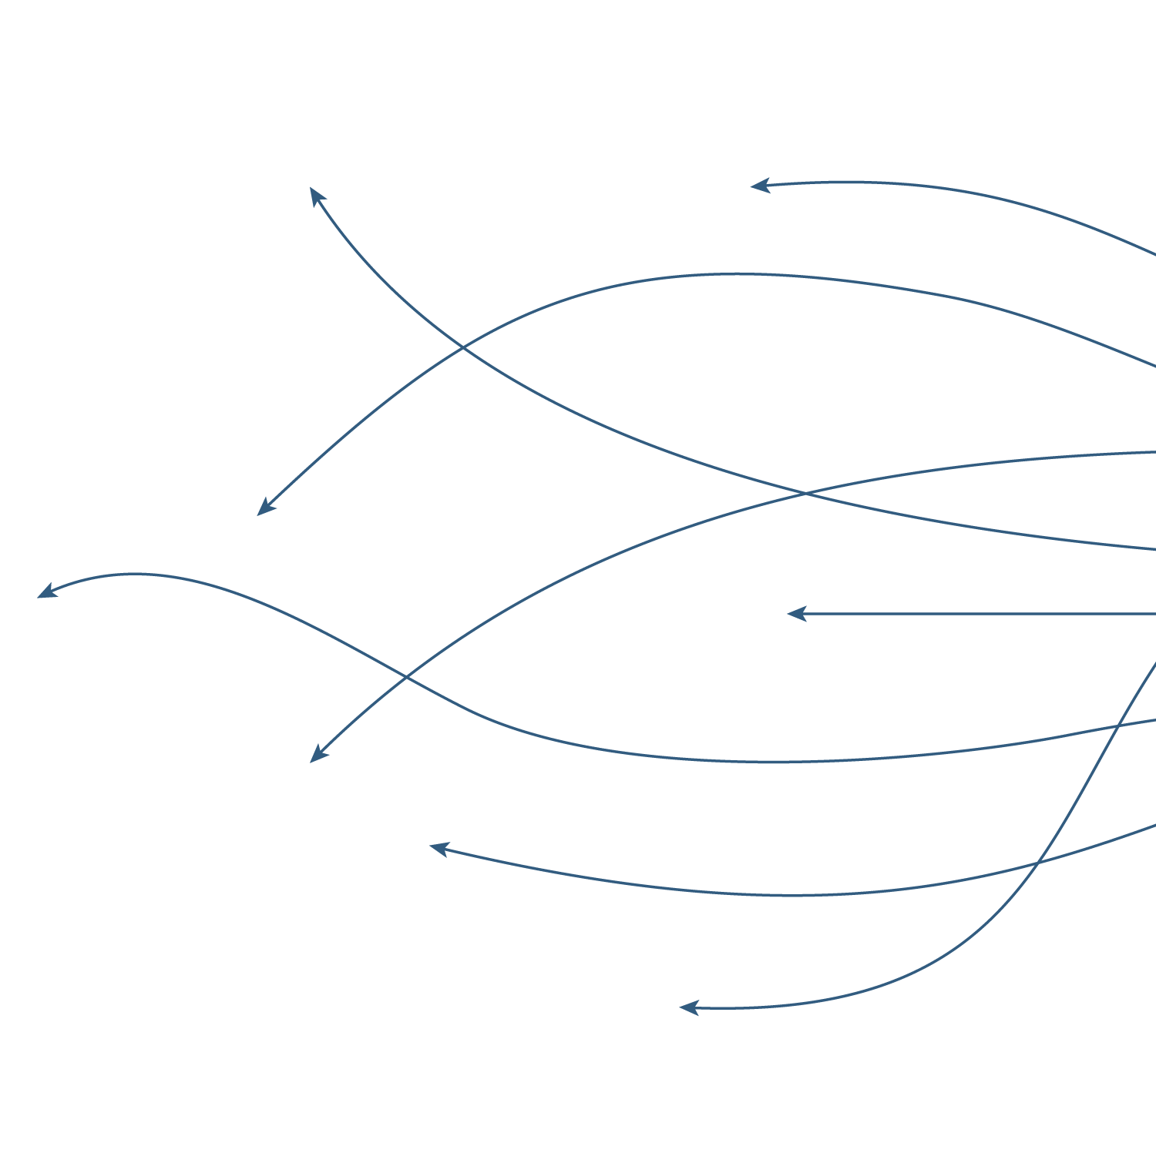



Last revision: June 10, 2020

# In case of security Incident

* DO NOT panic or react without a plan.
* DO NOT discuss the incident with others unless directed.
* DO NOT shutdown, power off or backup affected systems.
* DO NOT remotely access systems unless necessary.
* DO NOT use common privileged domain credentials.
* DO NOT install or execute any software on the systems.
* DO NOT conduct Anti-Virus or similar scanning processes.
* DO NOT attempt to retaliate against perpetrators.

**Call IRIS Hotline number and ask for support.**

# List of X-Force IRIS Hotline Numbers

## Worldwide

+1 312 212 8034

## Asia and Pacific

|  |  |
| --- | --- |
| **Country** | **Number** |
| Australia | (+61) 1 800 637 539 |
| Philippines | (+63) 1800 1611 0322 |
| Thailand | (+66) 1800 011 806 |
| New Zealand | (+64) 0800 426 111 |
| Malaysia | (+60) 1800 818 276 |
| Singapore | (+65) 800 616 7095 |
| India | (+91) 0008 000 401 045 |
| Indonesia | (+62) 00 180 361 859 |

## Europe

|  |  |
| --- | --- |
| **Country** | **Number** |
| Denmark | (+45) 4331 4987 |
| Finland | (+358) 972 522 099 |
| France | (+33) 157 327 272 |
| Germany | (+49) 693 8079 1120 |
| Italy | (+39) 029 995 3631 |
| Latvia | (+371) 66 163 849 |
| Netherlands | (+31) 707 709 351 |
| Norway | (+47) 23 024 798 |
| Poland | (+48) 223 062 234 |
| Portugal | (+351) 213 665 622 |
| Spain | (+34) 910 507 799 |
| Sweden | (+46) 850 252 313 |
| Switzerland | (+41) 227 614 228 |
| UK | (+44) 203 684 4872 |

## Japan

(+81) 356 952 751

## Middle East and Africa

|  |  |
| --- | --- |
| **Country** | **Number** |
| UAE | (+971) 80 004 442 417 |
| Saudi Arabia (landline) | (+966) 800 844 3872 |
| Saudi Arabia (mobile) | (+966) 800 850 0399 |

## North America

|  |  |
| --- | --- |
| **Country** | **Number** |
| USA & Canada | (+1) 888 241 9812 |